Introduction to Hive:

Apache Hive is a data warehouse system built on top of Hadoop and is used for analyzing structured and semi-structured data. It provides a mechanism to project structure onto the data and perform queries written in HQL (Hive Query Language) that are similar to SQL statements. Internally, these queries or HQL gets converted to map reduce jobs by the Hive compiler.

Use case :

County based

Creating Table covid Vaccine in Hive :

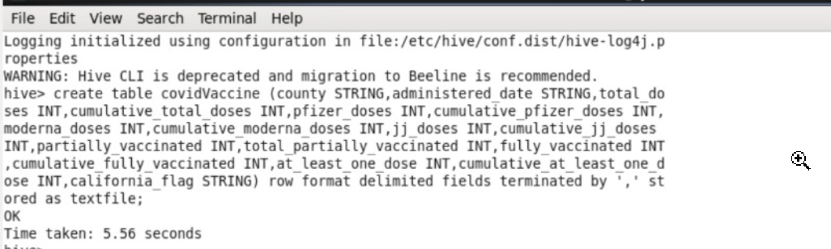

Loading data In Hive :

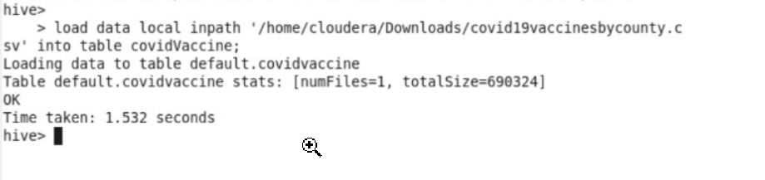

Data in table covidVaccine:



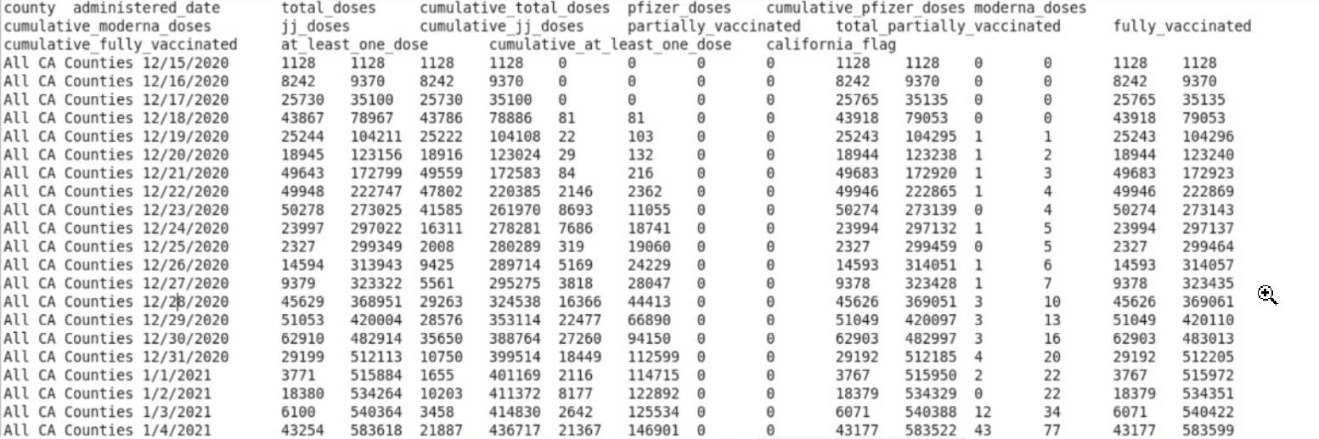

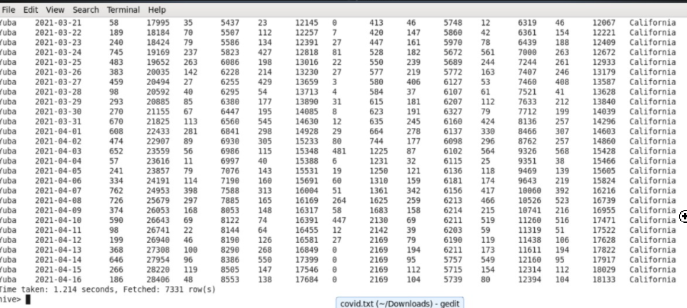

Cities being considered in that county for vaccine supply :

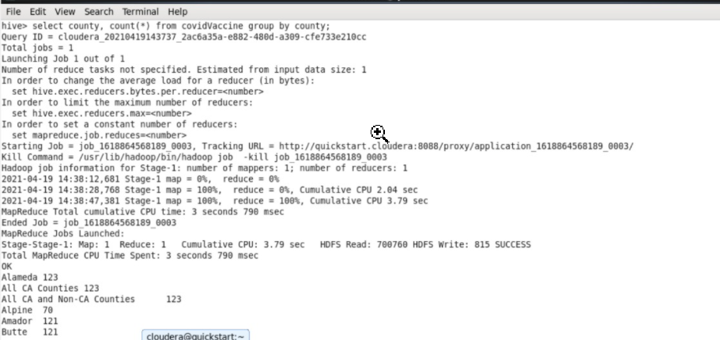

How much Supply of doses (maximum doses) is going to particular county

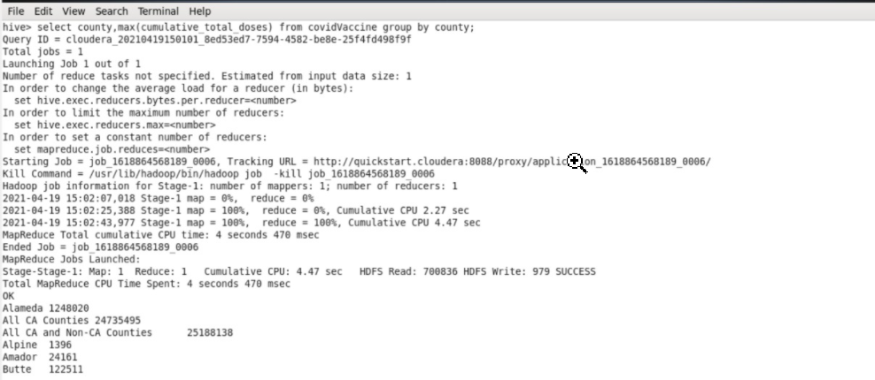

Maximum doses of **individual vaccines** in each county:

